**CO2 Emissions Complete Dataset 1750-2020**

Complete Data set of CO2 emissions per country and related variables ( RAW )

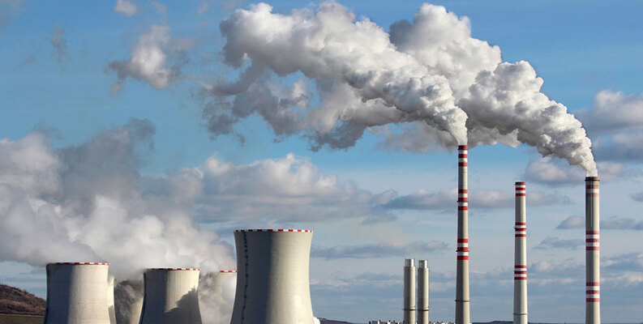

Data Card

Code (0)

Discussion (0)

**About Dataset**

This is the raw data set of CO2 emissions(kT) by every country from 1750 to 2020.  
There are 25990 rows of data and 60 columns including every factor that affects the emission along with emission rates of methane and nitrous oxide.

Atmospheric ScienceGeography